Prompt
Volatility Modeling: PO – S2.H1
Background and Purpose
By responding to this Request for Proposal (RFP), the Proposer agrees that s/he has read and
understood all documents within this RFP package.
Submission Details
Responders to this RFP should supply:
• A business report up to 5 pages, including any supporting plots and tables.
The report should address all points described in the “Objective” section below.
The report should be returned in the following way:
• Electronic (submit on Moodle)
Objective
The Commercial Banking Corporation (hereafter the “Bank”), acting by and through its department of
Portfolio Pricing is seeking proposals for banking services. The scope of services includes the following:
• Collecting of daily stock prices and daily returns for the 30 stocks in the Dow Jones Industrial
Average (DJIA).
• Ranking these 30 stock components of the DJIA by most significant to be predicted with
ARCH/GARCH modeling.
o The Bank’s analysts recommend using the Lagrange Multiplier Lag 1 test p-values to
make this ranking; the Bank is open to other proposals as long as they are clearly stated
and supported.
• Creation of a series of five models to predict the volatility from the top five most significant
stock components of the DJIA to be predicted with ARCH/GARCH modeling.
o The Bank’s analysts recommend using the top 5 stock components ranked by the LM
test previously calculated.
o The Bank’s analysts recommend picking one of the following models: GARCH(1,1)-
Normal, t-GARCH(1,1), QGARCH(1,1)-Normal, QGARCH(1,1)-t; the Bank is open to other
proposals as long as they are clearly stated and supported.
o The Bank’s analysts recommend picking the best model based off of lowest BIC value;
the Bank is open to other proposals as long as they are clearly stated and supported.
• Forecast of the next 30 days of volatility for each of the five models mentioned above.
• Rank these five stocks by order of most likely to be bothered by a shock to the market today.
• Rank these five stocks by order of longest effect a shock lasts; compare this to the previous
ranking and interpret.
Data Provided
No data is provided to the consulting team for this analysis. All data must be gathered by the team itself
through any means it desires. The dates for the data you should pull are March 1, 2011 to March 24,
2021.

Breakdown
Breakdown here

Report

Report is subtab

Code and Plots

Report Here

Assessing Volatility Risk and Shock Persistence in Dow Jones Industrial Average Stocks

Homework Team 4
Lukman Awad, Irvin Carreon, Seamus Flaherty, April Groce, Grayson Nico

February 27, 2026

Table of Contents

Overview 1
Methodology 1
Data Used 1
Data Preprocessing 1
Analysis 1
Stock Selection 1
Model Creation & Selection 2
Results & Recommendations 3
Stock Ranking 3
Recommendations 4
Conclusion 5

Assessing Volatility Risk and Shock Persistence in Dow Jones Industrial Average Stocks

Overview
The Commercial Banking Corporation (hereafter the “Bank”), acting by and through its Portfolio Pricing Department, has requested an assessment of stock volatility among the components of the Dow Jones Industrial Average (DJIA). Therefore, our team forecasted stock volatility among the top five most significant stock components of the DJIA using Autoregressive Conditional Heteroskedasticity (ARCH) and Generalized ARCH (GARCH) methodologies to support portfolio pricing and risk management decisions. Our analysis identified the following stocks as the most significant for volatility modeling:
- Goldman Sachs Group Incorporated (GS)
- Honeywell International Incorporated (HON)
- Procter & Gamble Company (PG)
- JPMorgan Chase & Company (JPM)
- Microsoft Corporation (MSFT)
Amongst these five stocks, GS stocks exhibited the highest sensitivity to market shocks, while HON demonstrated the longest recovery period following market shocks. Overall, our analysis indicated that DJIA represents a dependable investment area for the Bank’s services, as its most volatile assets provide a reliable combination of high risk and stability.

Methodology
The following section describes the structure and preparation of the data used to rank stock resilience and forecast stock volatility.

Data Used
Our team collected daily stock prices and returns from the 30 companies currently included in the DJIA from March 1st, 2011 to March 24th, 2024. The current DJIA portfolio consisted of major corporations such as Amazon, Walmart, Nike, and Cisco Systems.

Data Preprocessing
To prepare for our analysis, we calculated both simple returns and logarithmic returns for each stock using daily closing prices. We ensured that the data was in a tidy format, with prices and returns correctly aligned by date, to help facilitate accurate and efficient modeling of volatility patterns.

Analysis
This section details the selection of the most significant stocks in the DJIA, and describes the creation and evaluation of volatility models.

Stock Selection
Using ARCH/GARCH methodologies, we ranked the 30 stocks components of the DJIA based on their significance. The goal was to identify the stocks most appropriate for GARCH modeling and narrow the analysis to the five stocks with the strongest evidence of time-varying volatility.
We used the Lagrange Multiplier Lag 1 test to determine if a stock’s squared residuals were significantly correlated with past values. Any stocks that produce significant results from this test indicate that GARCH modeling is appropriate, due to the presence of volatility clustering within that stock. Therefore, this test allowed us to identify the top five most significant stocks for ARCH/GARCH modeling. Table 1 lists these stocks in descending order of significance.

Table 1: Lagrange Multiplier Lag 1 Test Results
Ticker Symbol | Company | P-Value
GS | Goldman Sachs Group Incorporated | $6.334×{10}^{-145}$
HON | Honeywell International Incorporated | $8.462×{10}^{-144}$
PG | Procter & Gamble Company | $3.553×{10}^{-141}$
JPM | JPMorgan Chase & Company | $3.774×{10}^{-136}$
MSFT | Microsoft Corporation | $6.719×{10}^{-116}$

The stocks displayed in Table 1 exhibited the strongest evidence of time-varying volatility based on their respective p-values and were expected to provide the most meaningful insight. In other words, these five stocks contributed most strongly to the volatility behavior in the DJIA.

Model Creation & Selection
For each of the five selected stocks, multiple ARCH/GARCH models were developed to capture different characteristics of volatility behavior. These models vary in complexity, distributional assumptions, and their ability to account for asymmetry after market shocks. The following models were used for estimation and their characteristics are shown in Table 2.

Table 2: ARCH/GARCH Model Characteristics
Model | Distribution | Symmetry | Complexity | Key Characteristic
GARCH-normal | Normal distribution | Symmetric | Low | Underestimates extreme movements.
GARCH-t | T-distribution | Symmetric | Low | Accounts for heavy-tailed distributions.
EGARCH-t | T-distribution | Asymmetric | High | Captures asymmetric volatility patterns.
GJR-GARCH-t | T-distribution | Asymmetric | High | Allows for positive and negative shock responses.
APARCH-normal | Normal distribution | Asymmetric or Symmetric | High | Allows for varied volatility dynamics.
We decided to incorporate asymmetry through the EGARCH-t and GJR-GARCH-t models in Table 2.

Model performance for each stock was measured using the Bayesian Information Criterion (BIC). The model with the lowest BIC value was selected as the best model for volatility forecasting. Across all five stocks, the GJR-GARCH model had the lowest BIC values, indicating that the model did well at fitting the asymmetric volatility at the expense of model parsimony.

Results & Recommendations
This section describes the volatility forecasts and stock resilience amongst the five stocks from above.

To evaluate risk, we generated a 30-day volatility forecast for each stock using the GJR-GARCH-t model, which captures asymmetric responses to market shocks. The t-distribution was used to accommodate the heavy distribution tails of each stock. Figure 1 shows the 30-day forecast for all five stocks.

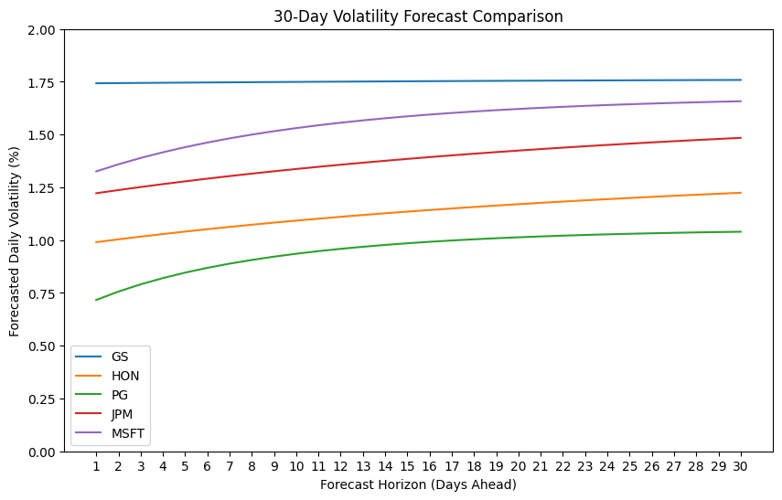
Figure 1: 30-Day Volatility Forecast Comparison

As seen in Figure 1, volatility increases over the projected 30 days with no sharp deviations.

Stock Ranking
From each of our models, we are able to pull alpha and beta parameters to get a better understanding of the volatility of each of these five stocks.

The alpha parameter for each stock’s respective model is listed in Table 3 in descending order.

Table 3: Stock Sensitivity to Shocks
Ticker Symbol | Company | Alpha
GS | Goldman Sachs Group Incorporated | 0.0394
MSFT | Microsoft Corporation | 0.0273
PG | Procter & Gamble Company | 0.0225
JPM | JPMorgan Chase & Company | 0.0202
HON | Honeywell International Incorporated | 0.0134

From Table 3, we saw that GS had the largest alpha parameter, indicating it is the most sensitive to market events. HON had the smallest alpha parameter, indicating that it was the least sensitive to market events.

In addition to pulling the alpha parameter from each stock’s respective model, we also evaluated the beta parameter, which is displayed in descending order in Table 4.

Table 4: Stock Recovery Ranking
Ticker Symbol | Company | Beta
HON | Honeywell International Incorporated | 0.9055
GS | Goldman Sachs Group Incorporated | 0.8881
JPM | JPMorgan Chase & Company | 0.8866
MSFT | Microsoft Corporation | 0.8748
PG | Procter & Gamble Company | 0.8740

Table 4 shows that HON had the largest beta parameter, which means that volatility for that stock takes the longest to decay following a market event when compared to the other four analyzed stocks. In contrast, PG had the smallest beta parameter, which means that it recovers most quickly.

Recommendations
As indicated by the alpha and beta parameters estimated from our GARCH models, the DJIA stocks exhibit a wide range of risk behaviors and volatility characteristics. Some stocks, such as GS, demonstrate high sensitivity to market shocks with a long recovery time, indicating that managing exposure to this asset may require repeated hedging strategies. Other stocks, such as PG, show lower sensitivity and faster recovery, implying a lower risk and more predictable volatility. Given this diversity, the DJIA represents a dependable investment area for the bank, offering opportunities for both high-return, higher-risk positions and more stable, lower-risk growth allocations.

Conclusion
Overall, we’d recommend DJIA for banking services, as these five stocks seem to be predictably volatile together. Though this group of stocks include those that experience amplified shock sensitivity and overall higher risk, such as GS, it also includes low-sensitivity stocks like HON and JPM. These latter stocks would be good candidates for long-term investments. Though these five stocks are only a small portion of the total 30 in the Dow, they capture a large share of DJIA conditional variance behavior. Whether its investments, benchmarking, or future modeling, our analysis shows that DJIA would be reliable enough for the Bank’s services.

HW Report Checklist

Homework Report Checklist - Team 4

As instructed by Hiya and Dr. Egan Warren, the team member(s) responsible for checking each item should enter their initials in the field next to each question. All items should be addressed before submitting the assignment with the initialed checklist attached.

Sections & Structure

Overview
LA | Is the overview concise?
LA | Does it provide context about the business problem? <Content>
LA | Does it briefly address your team’s work, quantifiable results, and recommendations? <Action>
LA | Does it offer audience-centered reasons for recommendations? <Context>

Body Sections
AG | Does the report body include information on methods, analysis, quantifiable results, and  recommendations?
AG | Is content grouped into appropriate sections (methodology, analysis, results, recommendations)?

Conclusion
AG | Does the report have a conclusion?
AG | Does the conclusion sum up the report and emphasize relevant takeaways?

Structure
AG | Does each major section have a heading?
AG | Are sections, subsections, and paragraphs organized logically for easy navigation?

Visuals

Introduction, Discussion, and Captions
IC | Is each visual introduced in the text before it appears?
IC | Is each visual close to where it is introduced?
IC | Does each visual include a title with the following information: type (table or figure), number, and a  descriptive caption?
IC | Is each visual discussed and interpreted in the text?
IC | Are figures and tables numbered separately?
IC | Are table captions above the table? Are figure captions below the figure?

Visual Design
IC | Do figures/tables use audience-friendly labels rather than variable names?
IC | Are the visuals easy to interpret?
IC | Are the visuals appropriately sized?
IC | Do tables appear on one page (not split between 2 pages)?
IC | Are legends and axis labels included for figures?
IC | Are numbers in tables right aligned?
IC | Are the visuals designed well (ex: re-created in Word or Excel, not blurry or stretched,…)?

Document Design

Title Page Design
IC | Does it include a descriptive title?
IC | Does it state the team name, team members’ names, and the submission date?

Table of Contents Design
SJF | Does it list all the major sections of the report with corresponding page numbers?
SJF | Do the page numbers and sections in the Table of Contents match the report?

Document Design for Entire Report
SJF | Is a standard typeface (Calibri, Arial, etc.) used?
SJF | Is the size of the body text between 10-12 pt.?
SJF | Are headings and subheadings used to organize information?
SJF | Are distinctive text styles (bold, italic, etc.) used to distinguish between heading levels?
SJF | Are text styles for headings used consistently (ex: all level-one headings are bold)?
SJF | Are all paragraphs an appropriate length (fewer than 12 lines)?
SJF | Is white space used to indicate paragraph breaks?
SJF | Are bullet lists used for a series of items and numbered lists to show a hierarchy?

Writing Style and Mechanics

Spelling and Capitalization
GN | Are spelling errors located and corrected?
GN | Is spelling consistent throughout (no switching between acceptable spellings)?
GN | Is capitalization used appropriately (proper nouns, etc.)?
GN | Is capitalization of words consistent throughout the report?

Grammar and Punctuation
GN | Are verb tenses used appropriately?
GN | Are marks of punctuation used appropriately?
GN | Is subject-verb agreement used in every sentence?
GN | Is the grammar checker updated and are underlined grammar issues addressed?

Writing Style
GN | Are all sentences in the report easy for your audience to understand quickly?
GN | Are most sentences written in active voice?
GN | Are idioms and vague words eliminated from the report?
GN | Are acronyms introduced before being used?
GN | Are well-written topic sentences included at the beginning of each paragraph?
GN | Are lists parallel?
GN | Is the appropriate point of view used when addressing your audience or describing team actions?

